Detective’s Name _____________________________

The Mystery at Eatum Hall

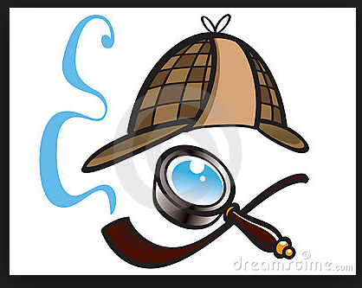
Let's use clues to make inferences! Collect the clues to determine Dr. Hunter's true purpose, or motive, for inviting the Pork-Fowlers to Eatum Hall.

Why do you think the door was open, the lights were off, and there was no one to greet the Pork-Fowlers when they arrived?
___________________________________________________________________________________
_________________________________________
_________________________________________

What are the spelling mistakes in the letter that can act as clues to Dr. Hunter's true purpose?

_____________________________________ and _________________________________________

Look at the collections of paintings that the Pork-Fowlers noticed while exploring. What do you notice about them? Why are they clues to Dr. Hunter's true motive?
___________________________________________________________________________________
_________________________________________
_________________________________________

The portrait over the fireplace has eyes that move. Infer.
___________________________________________________________________________________
_________________________________________
_________________________________________

Look carefully at the book titles. What can you infer?
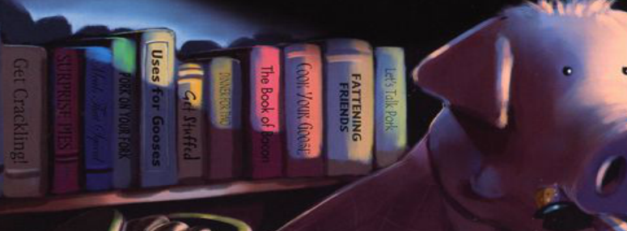
___________________________________________________________________________________
_________________________________________
_________________________________________

Look carefully at the illustrations. Note what you notice.
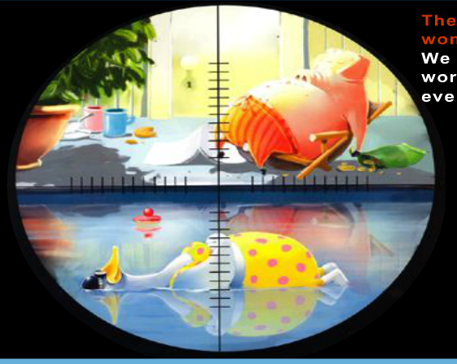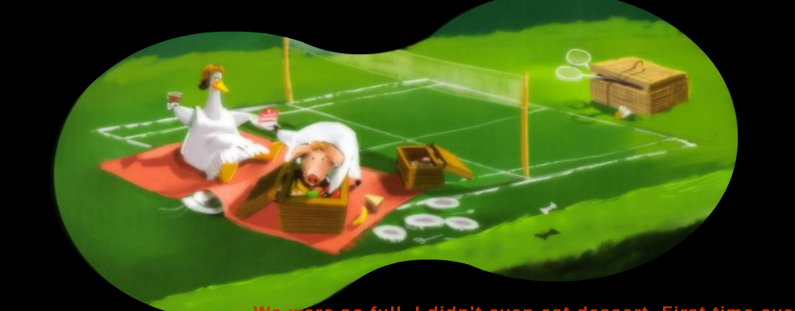

___________________________________________________________________________________
_________________________________________
_________________________________________

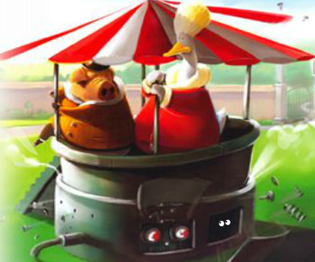
What do you think the "Bandstand" really is? Why do you think this?

___________________________________________________________________________________
_________________________________________
_________________________________________

Cycle 3 Week 1 CFA: (Questioning, Inference, and Interpretation RL 4.1 and RI 4.1)

So, Detectives, what do you think Dr. Hunter's true purpose, or motive, was in inviting the Pork-Fowlers to Eatum Hall for the weekend? Use your inferences to write your response.
___________________________________________________________________________________
_________________________________________
_________________________________________
___________________________________________________________________________________
_________________________________________
_________________________________________
___________________________________________________________________________________
_________________________________________
_________________________________________
___________________________________________________________________________________
_________________________________________
_________________________________________

